**Autonomous Vehicles**

**What do autonomous vehicles do?**

Autonomous vehicles are self-driving or computer-driven forms of transport - usually cars- that do not require the full control of a human or none at all to operate safely on the road. In 2016 the Society of Automotive Engineers (SAE) created a standard for Levels of Driving Automation J3016 - <https://templatelab.com/automated-driving/> - that include levels 0 through to 5. Here is their original description of these levels:

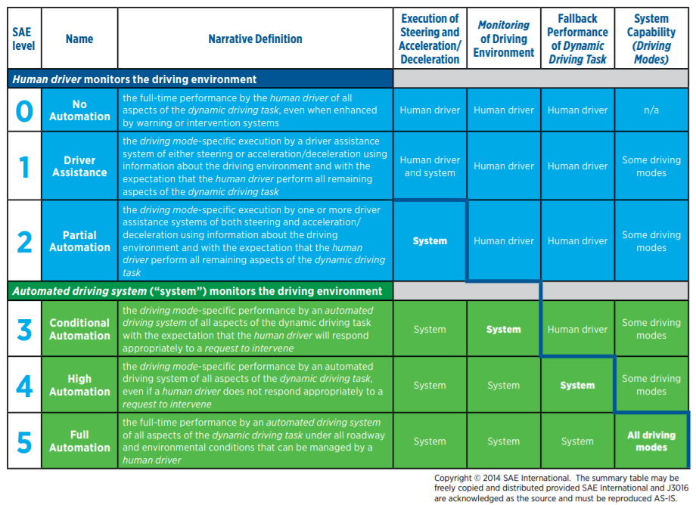

**What is the state of the art of this technology?**

Driverless cars are capable of using a wide range of technologies in order to function safely in a constantly changing traffic environment. Here is some of the most up to date technology:

* High resolution cameras are placed on every side of the care and are used to get a 360-degree view of the surroundings. These cameras vary in their field of view, some being wide and having a short range, others being narrow with a longer range. Cameras create a great 2D picture of what is around the car but cannot provide depth of vision for the computer to understand. Additionally, cameras are quite limited in their effectiveness in dark, dusty, foggy, snowy or rainy environments. High resolution cameras must be used alongside other technologies in order to give cars autonomous functions.
* Radar is the use of radio waves to detect the location and speed of other objects - usually cars. This is done by sending out pulses of radio waves that bounce back off of objects. The returning radio waves are then sensed by the car and provide information on the proximity of surrounding objects. Radar can also be used by boats, ships, aircrafts and meteorologist to detect weather changes.
* Light detection and ranging (LiDAR) is the use of lasers to create a 3D image of the earth or objects. These lasers are fast and invisible and function similarly to radar. However, LiDAR detects much more information so provides more opportunity for car autonomy.
* Thermal cameras are used to detect living things such as people and animals in a traffic environment. This can aid greatly in developing safety measures for driverless cars because the safety of humans should be the number on priority.
* Ultrasound is similar to radar in that it sends out signals to measure how quickly they bounce back to get an idea of how far away objects are. This can be very accurate at short distances in clear environments. For this reason, ultrasound is often used in cars to aid with self-parking.
* Global navigation satellite systems (GNSS) or global positioning systems (GPS) are used to approximate where the car is on the globe. This can be accurate up to a few meters or more. While this is not a new technology, it is still used by the autonomous vehicles made today.
* Inertial measurement units (IMUs) are used to identify the position and movements of the car, where it has been and where it is now.

**What can be done now?**

The most well known and advanced technology in this area seems to be Waymo One. Waymo One is Google’s sister company that launched its first commercial autonomous taxi service within the metro Phoenix area in December 2018. The service was first provided to just a few select customers who were a part of the Early Rider Program. These cars were always accompanied by a driver at the time but now that the Waymo One service is available to the rest of the public in the metro Phoenix area, some of the autonomous cars are completely driverless. The Early Rider Program is still in progress in order to provide early feature access and to collect valuable research on these features. Waymo One is considered to be at level 4 in driving automation as it is still restricted to the Phoenix area and still require drivers some/most of the time for safety but essentially do all of the driving themselves.

As far as autonomous cars that are available to the public, Tesla is probably leading the way. They already provide cars that are well and truly classified as level 2, some have level 3 functions and in a select few circumstances these cars can have level 4 capabilities. However, these cars are said to be capable of level 5 autonomy after some software updates.

“I remain confident that we will have the basic functionality for level 5 autonomy complete this year” - Elon Musk, CEO of Tesla, at the China AI Conference in July 2020.

With Waymo One already having level 5 autonomous cars and Tesla stating that they plan to reach level 5 autonomy this year, it seems that in less than three years’ time the public will have access to purchase the vehicles and they will already be adapting to different American states, different countries and different traffic conditions on their own. Due to the initial cost of these level 3, 4 and 5 vehicles it is unlikely that they will become widely used within three years but levels 1 and 2 are already accessible at most car dealerships in the western world.

**What is the likely impact? (300 words)**

There are and always have been many safety concerns related to autonomous vehicles or any technology that has control over human lives. Placing our lives in the hands of robots that do not possess morals to guide them is unnerving to say the least. There are many questions that may need to be answered before the general public can feel comfortable around these machines. For example, are pedestrians always safe around these cars? Will level 5 cars be able to ensure the safety of the people inside? Are these cars more or less safe than human-driven cars? There may also be moral questions such as, can the car’s choices (e.g. parking preference or speed) be altered to suit the owner or passengers? Should they be altered? Who is at fault when these cars make mistakes, the driver or the manufacturer?

Another thing to consider is security. Autonomous cars are run by a computer or several computers which leads to the possibility of hacking concerns. While the manufacturers will most likely have considered this thoroughly, can they guarantee that their systems will not be compromised? Autonomous cars that use satellite or GPS may raise concerns about location security. Both physical safety and cyber safety will need to be considered when developing or purchasing autonomous cars.

These cars would surely function better if the roads were catered to autonomous cars, rather than human-driven cars. If driverless cars become popular there could be major changes in how roads are initially made or updated. If the road communicates with the car rather than just the car detecting the road then this could lead to more efficiency and better safety precautions. Our roads could look very different if autonomous driving becomes mainstream.

Tesla is well known for their electric cars which could lead to more sustainable options such as solar power. If driverless cars are run on electricity rather than petrol, that could be a big step in the direction of reducing the currently negative impact that cars have on the earth.

**Which people will be most affected and how? Will this create, replace or make redundant any current jobs or technologies?**

**How will this affect you? (300 words) In your daily life, how will this affect you? What will be different for you? How might this affect members of your family or your friends?**

Resources:

Waymo One: <https://waymo.com/>

<https://blogs.nvidia.com/blog/2019/04/15/how-does-a-self-driving-car-see/>

<https://www.wevolver.com/article/2020.autonomous.vehicle.technology.report>

<https://www.aitrends.com/ai-insider/proprioceptive-inertial-measurement-units-imu-self-driving-cars/#:~:text=Usually%20consisting%20of%20several%20gyroscopes,the%20vehicle%20(that's%20by%20the>

<https://blogs.nvidia.com/blog/2019/04/15/how-does-a-self-driving-car-see/>

<https://www.youtube.com/watch?v=SHOLLbFZXeE>

<https://thenextweb.com/shift/2020/02/27/6-levels-autonomous-self-driving-explained-tesla-waymo-autopilot/>

<https://www.tesla.com/en_AU/autopilot>

<https://www.ucsusa.org/resources/self-driving-cars-101>